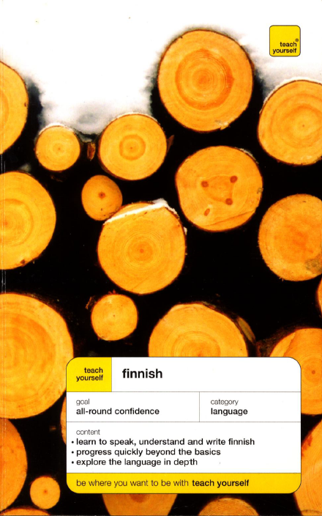

Teach Yourself Finnish
Author: Terttu Leney
Publisher: NTC/Contemporary Publishing Company
Publication date: 1993
Format: PDF (scanned pages)
MP3 (CBR 128kbps 44kHz mono, 3h 15m)
Number of pages: 373
Language: English
Site: http://www.teachyourself.co.uk/
- Do you want to cover the basics then progress fast?
- Do you want to communicate in a range of situations?
- Do you want to reach a high standard?

TYF starts with the basic but moves at a lively pace to give you a good level of understanding, speaking and writing. You will have lots of opportunity to practise the kind of labguage you will need to be able to communicate with confidence and understand the culture of Finland.

Terttu Leney has taught Finnish to adults and teachers of Finnish for over 20 years and has worked at the BBC World Servise

